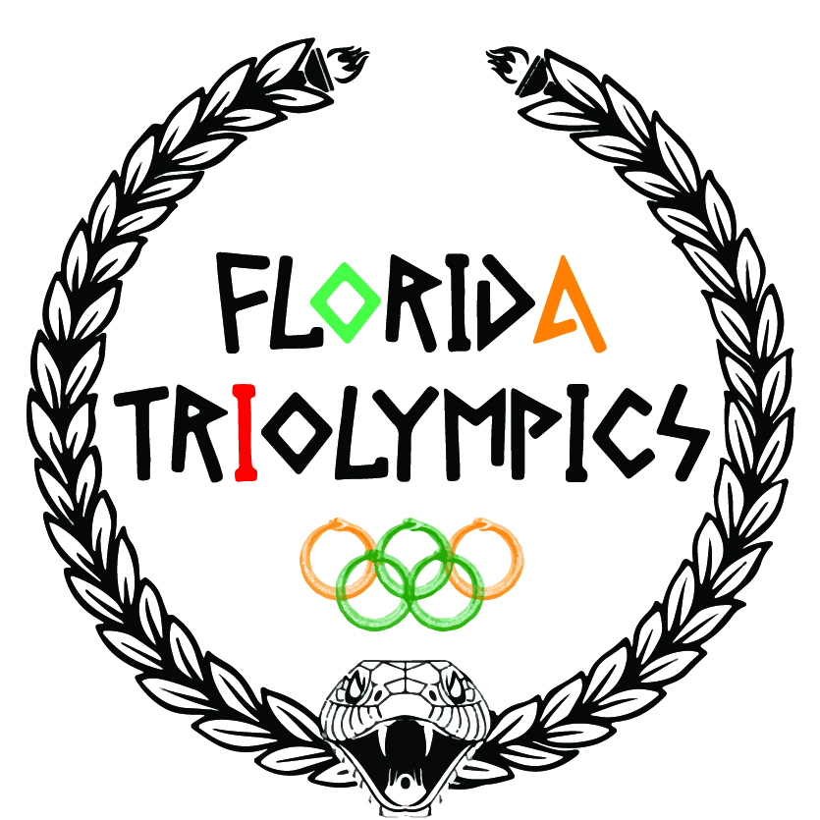

July 13-15, 2017
Florida A&M University
Tallahassee, FL

Please mark your calendars for the 48th Annual FL TRiOlympics. July 13th will be early registration and campus tours. All Olympic events will be held July 14 and 15. Events to include:

Chess | Checkers | Spades | Creative Writing
Art & Photography | Basketball | Co-Ed Softball | Volleyball
Co-Ed Soccer | Track | Cheerleading | Spelling Bee
Public Speaking | Scholar’s Bowl

In addition, the TRiOlympics Showcase will include the :
- Mr. and Mrs. TRIO/UB Recognition Tribute
- TRIO Stepshow Competition
- Talent Competition

Also, this year we will be introducing the newest event: SAT Prep Competition!
More information to come shortly. Please join us for camaraderie and competition.
Fltrio.weebly.com/Olympics

