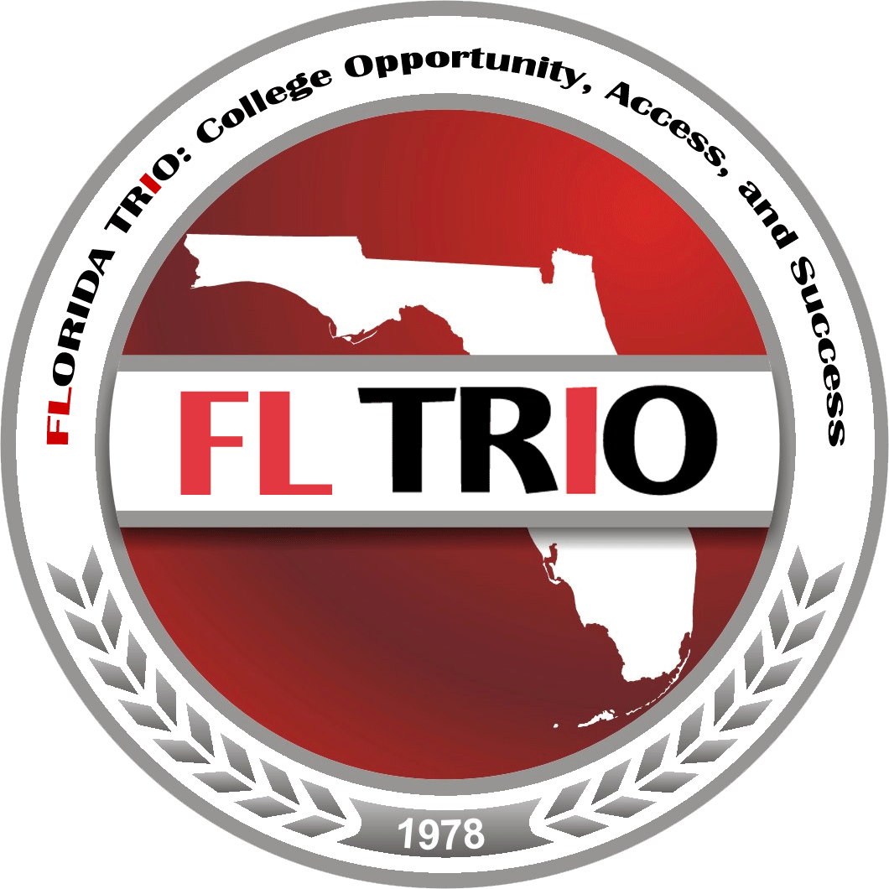

2017
NOMINATIONS
&
ELECTIONS
PACKET
2017 Nominations & Elections Packet
Table of Contents
Topic | Page
Letter from the President ………………………………………………………………… | 3
History of Florida TRIO ……………………………………………………………………… | 4
Florida TRIO Purpose and Objectives………………………………………………………… | 5
Nominations & Elections Guidelines ……………………………………………………. | 6
Qualifications for Office …………………………………………………………………. | 7
Officer Duties and Responsibilities ……………………………………………………… | 7
- President ………………………………………………………………………….. | 7
- Vice-President ……………………………………………………………………. | 7
- Treasurer …………………………………………………………………………. | 8
- Secretary …………………………………………………………………………. | 8
- Members-at-Large ……………………………………………………………….. | 8
- Immediate Past-President ………………………………………………………… | 8
- Parliamentarian | 8
Tenure of Officers ………………………………………………………………………... | 9
Campaign Rules and Regulations ………………………………………………………... | 9
Nominations & Elections Timeline ………………………………………………………. | 10
Nomination Application ………………………………………………………………….. | 11

Florida TRIO, Inc.
PO Box 6384
Tallahassee, FL 32314

2015-2017
Board of Directors

Lori Livingston
Tallahassee Community College
President

Jerinae Speed
Indian River State College
Vice President

Carrie Blaustein
University of South Florida
Secretary

Jovany Felix
Florida A&M University
Treasurer

Carlton Daley
Miami Dade College
Members –At-Large
South Region

Rachelle Burns
Pensacola State College
Members –At-Large
North Region

Beatrice Turpin-Peek
Eastern Florida State College
Members –At-Large
Central Region

Raymond Cabrera
University of South Florida
Immediate Past-President

Florida TRIO Community,

Thank you so much for your continued support of Florida TRIO and your interest in seeking an elective office. This packet contains the information you will need to get started.

In addition to the information contained in this packet, candidates are strongly encouraged to become familiar with Florida TRIO’s Constitution and By-Laws. Should you be elected to office you will be afforded an opportunity to serve your state, build your leadership skills and make a meaningful contribution to Florida TRIO and in some instances, SAEOPP.

Rowina Harmon, Student Support Services Academic Advisor for Palm Beach State College, has volunteered to be the chair of the nomination committee. Nominations will be open until January 30, 2017. If you are interested in running for a position, please complete the Nomination Application in this packet (pages 11-16). Ms. Harmon may be reached by phone at 561-868-3396 or by email at harmonr@palmbeachstate.edu if you have any questions.

Josephine Carey Postsecondary Advisor for Student Support Services at Palm Beach State has volunteered to be the chair of the elections committee. Charlie can be reached at 561-868-4006 or by email at Careyj@palmbeachstate.edu. The Executive Board, Nominations Committee and Elections Committee are here to answer any questions you may have. Remember, we need you to continue building our state organization!

Thank you for your consideration of running for a leadership position in Florida TRIO.

Best Wishes,

Lori Livingston
Florida TRIO President

HISTORY OF Florida TRIO

The creation of the TRIO Programs began with the Educational Opportunity Act of 1964, the war on Poverty Statue, which created the Upward Bound Program. In 1965, the Higher
Education Act created Talent Search Program. The first reauthorization of the Higher Education
Act in 1968 created the Special Services Program. By 1968, the original TRIO Programs, the
Upward Bound, Talent Search, and Special Services were established. In that same year, the
Upward Bound Program was placed into the Higher Education Act.

The beginnings of the TRIO Programs in Florida can be clearly traced to Florida A&M University. In 1965, that institution was awarded a Federal Grant to conduct several nationwide pilot programs designed to afford low-income students the opportunity to attend college. The impetus for information of organizations such as Florida Association of Educational Opportunity
Program Personnel (FAEOPP) – now FL TRIO could have conceivably resulted from the assemblage of several Florida Upward Bound Directors in 1970, Tampa, Florida. These Upward Bound Directors
Meet at the University of South Florida under the direction of Richard F. Pride initiated an organization called Personnel in Special Programs.

In 1971, the Florida Personnel in Special Programs had another meeting in West Palm
Beach, Florida, to plan statewide Upward Bound activities and to establish collaboration linkages. Officials from the Department of Health, Education and Welfare-Office of Education, who also attended the meeting, were very impressed with the organization of the Florida group.
By 1972, each of the eight states in the Southeastern Region all had organizations similar to Florida's Personnel in Special Programs. These State Organizations having structure and leadership within them facilitated the Office of Education in the selection of key personnel for their Regional Advisory Board.

By 1973, selected representatives from each of the Southeastern States were chosen to be on the Advisory Board that was formed by the Program Officers of Region IV of the U.S. Office of Education. Richard F. Pride was the Chairman of the Advisory Board during the 1973-74 year. The Advisory Board members met periodically in Atlanta at the request of the Program Officers. In addition to representing their state, the Advisory Board members had the responsibility of planning conferences and providing input to the Regional Officials on matters concerning the TRIO programs. These Regional Advisory Boards, in retrospect, turned out to be a precursor to our present regional organizations.

In 1976, after several years of discussions concerning the formation of a regional organization that could openly advocate for the concerns and needs of the TRIO participants,
Southeastern Association of Educational Opportunity Program Personnel was finally organized.
However, ratification by all the states in the Southeastern Region did not occur until several years later.

On October 29, 1978, in Gainesville, Florida, the Florida Association of Educational
Opportunity Program Personnel was formerly organized commensurate with the ratification of the Constitutions and By-Laws of the Southeastern Association of Educational Opportunity Program Personnel (SAEOPP). In 1978, a total of fourteen (14) colleges and universities sponsored the original TRIO programs in the State of Florida.

Purposes & Objectives

The purpose of The Association shall be to bring together a community of persons who have an active interest in or who are professionally involved in broadening accessibility to and success in formal postsecondary education.

- The Association shall seek to accomplish its purpose:
    - by serving as an entity of representatives affiliated or employed by programs sponsored by the U.S. Department of Education, Florida Department of Education or Foundations in the state of Florida, along with other programs with an active/and or professional interest in broadening access to and success in post-secondary education;
- by gathering, evaluating and disseminating information about post-secondary educational opportunities to benefit low-income, first-generation, disabled and culturally disadvantaged individuals;
- by developing meaningful approaches to address the concerns of non-traditional prospective and/or enrolled non-traditional students;
- by expanding communication and providing educational enhancement for those interested in and/or involved in educational opportunity programs;
- by promoting research, evaluation, programmatic, and fiscal planning and training , inclusive of, but not limited to, conducting workshops and seminars generally seeking to educate the public officials to the concerns of The Association; and
- by encouraging the development and expansion of the communication network primarily for those professionally involved in educational opportunity programs.

- In order to meet the purpose, the Executive Board will establish and implement a Strategic Plan every three to five years.
- The Executive Board will establish and implement programming and/or operational goals annually and will advance and fulfill the goals of the Strategic Plan.
Nominations & Elections Guidelines

SECTION 3. ELECTIONS
- At least 90 days prior to the annual meeting of The Association, during the last year of the tenure of each of the members of the Executive Board, the nomination process will begin. The Nominations Committee will solicit from the eligible voting membership, names of eligible candidates to (as designated in Article IV, Section 3c) place in nomination for the offices of the Executive Board.
- At least 60 days prior to the annual meeting of The Association, the Nominating Committee will forward to the Vice-President the names of the candidates that have been placed in nomination. The Vice-President will certify that the candidates are eligible for office and forward the names on to the Executive Board who will approve the list.
- At least 45 day prior to the annual meeting of The Association, the Nomination Committee shall prepare an information sheet listing the qualifications of each candidate, which may include a brief statement from the candidates. The Committee will also prepare the ballot.
- At least 30 days prior to The Association’s annual meeting, all officers shall be elected by mailed or electronic ballot. Voting will remain open for 10 calendar days. The Elections Committee will receive and count the ballots.
- At least 15 days prior to The Association’s annual meeting, the Elections Committee shall certify the election and submit the results to the President who will announce the results to the membership.
Source: Florida TRIO Constitution & Bylaws (p. 12)
SECTION 3. SPECIAL COMMITTEES

  - Nominations Committee—This committee shall be responsible for the dissemination of a certified ballot to eligible members in accordance with Article V, Section 3d.
  - Elections Committee— This committee shall be responsible for certifying the election of officers. No member of this committee shall serve on the Nominations Committee at the same time. The Elections Committee shall open voting (by mailed or electronic ballots) at least 30 days prior to The Association’s annual meeting. Voting will remain open for 10 calendar days after which the Elections Committee will receive and count the ballots. At least 15 days prior to The Association’s annual meeting, the Elections Committee shall certify the election and submit the results to the President who will announce the results to the membership in accordance with Article V, Section 3e.
Source: Florida TRIO Constitution & Bylaws (p. 16)

Qualifications for Office

The Florida TRIO Board composed of individuals who TRiO professionals who are knowledgeable and have the desire to make a significant contribution to the deliberations of the Board and the Association. Board members should bring a broad range of experiences to the Board. According to the Florida TRIO Constitution, the following guidelines must be adhered to in order to be considered for an office:

EXECUTIVE BOARD (OFFICERS) OF THE ASSOCAITION
SECTION 1. OFFICERS

- Composition: The officers of The Association and its Executive Board shall be the President, Vice-President, Secretary, Treasurer, and three Members-At-Large (one for each region: north, central, and south). The Immediate Past-President will serve as an ex-officio (non-voting) member of the Executive Board of one year immediately after holding office in The Association.
- Candidates must be active members of The Association as delineated in Article IV, Section 3c of the Constitution & Bylaws.
- Candidates for office must have completed The Association’s Emerging Leaders Institute before they can be considered for office.
- Candidates must have been actively involved in Florida TRIO for at least one year before they can be considered for office.

Offices & Duties

According to the Florida TRIO Constitution, the following are the duties for each office:

EXECUTIVE BOARD (OFFICERS) OF THE ASSOCAITION
SECTION 1. OFFICERS

- Duties:

  - President— The President shall be the chief executive officer of The Association and shall be at the Annual Meeting of the Association. The President will be the Chairperson of the Executive Board and shall, with the advice and consent of the Executive Board, make all appointments to standing, special, and ad hoc committees. The President will be an ex-officio (non-voting) member of all committees. The President will represent The Association on the Executive Board of the regional organization (SAEOPP).

  - Vice-President— The Vice-President shall serve with the same powers and authority of the President in the absence of the President and/or in the event that the President becomes incapacitated or resigns. The Executive Board will determine incapacitation. The Vice-President shall be the Chairperson of the Legislation and Education Committee. Additionally, the Vice-President will be the Florida TRIO Representative on the SAEOPP Conference Committee. The President may designate the Vice-President as an ex-officio (non-voting) representative on any other committee.

  - Treasurer— The Treasurer is responsible for the day-to-day oversight of the Association’s funds including the receipt and disbursement of all funds in accordance to fiscal policies established by the Executive Board at the Association’s expense, the treasurer will be bonded. He/She provides a signature on checks following the procedures outlined in the Association’s Policy on Financial Administration. The Treasurer shall maintain appropriate and adequate financial records and shall be prepared, at any time, to surrender such records and monies to the Executive Board or to the succeeding Treasurer. The Treasurer shall submit a written report at each Executive Board meeting and the Annual Meeting. The Treasurer shall submit a fiscal report at the termination of her/his office. The treasurer shall review fiscal policy and procedures (aided by the Finance & Fiscal Concerns Committee) to insure that the Association is operating according to the Constitution and Bylaws. The Treasurer will serve as an ex-officio (non-voting) member of the Finance & Fiscal Concerns Committee, Conference & Activities Committee and serve as the Co-Chair of the Membership and Credentials Committee.

  - Secretary— The Secretary shall have both recording and correspondence responsibilities and will be responsible for maintaining up-to-date records concerning membership status. The Secretary shall serve as serve as the Co-Chair of the Membership and Credentials Committee. and the Conference & Activities Committee. It shall be the responsibility of the Secretary to incorporate quarterly reports of the President, Vice-President, Treasurer and Committee Chairpersons into the records of The Association.

  - Member-at- Large— The Member-at-Large shall be elected to represent three geographical regions of Florida (North, Central and South) that make up The Association. The Member-at-Large will represent the diverse program interests of the membership and are voting members of the Executive Board. Each Member-at-Large will be the Chairperson of one of the three following committees (Newcomers & Alumni, Media & Technology, and Awards, Recognition & Student Initiatives). Members-at-Large will also serve on the Association’s Fair Share Committee.

  - The Immediate Past-President shall serve as an ex-officio (non-voting) member of the Executive Board for a term of one year to provide guidance to the President and the Executive Board and for continuity from the previous Board to the new Board.

  - Parliamentarian-- The Parliamentarian will make certain all proceedings of the Association and Executive Board are conducted in accordance with the most up-to-date Robert's Rules of Order. Additionally, he/she (1) advises the president and other officers, committees, and members on matters of parliamentary procedure, (2) assists with procedure during conventions and board meetings, (3) trains officers and committee chairs, (4) supervise credentials and elections, and (5) assists with the creation or revision of bylaws. This position is a currently appointed by the President and is not an elected office.

  - Fair Share Liaison is in charge of the management and coordination of COE's fair share campaigns. This includes developing a Fair Share Team, making contacts with colleagues, obtaining information form COE, and maintaining the list of Fair Share contributors. This position is a currently appointed by the President and is not an elected office.

Tenure of Officers

EXECUTIVE BOARD (OFFICERS) OF THE ASSOCAITION
SECTION 4. TENURE

- The term of officers shall be two years, except for the Immediate Past President, who serves a one-year term. The term of office shall begin at The Association’s annual conference.
- Officers cannot serve consecutive terms in the same office. If there are no nominees for an office, the President, with the consent of the Executive Board, may appoint an eligible member of The Association (in accordance with Article IV, Section 3c and Article V, Section 1. for a term to be approved by the Executive Board.

Campaign Rules

It is expected that all candidates will conduct their campaigns in an honest and ethical manner, with particular consideration given to the rights and privileges of fellow candidates. The purpose of these campaign rules is to assist members running for Florida TRIO office to conduct their campaign in a way that will provide equal opportunity for candidates to inform members of their qualifications.

1. General Guidelines
- The Campaign Rules are meant to ensure fairness, keep order, and preserve the integrity of the election. In general, candidates should try to maintain the “spirit of the campaign” which is an atmosphere of friendly competition with others and respect for the election process.
- Members should: (a) avail themselves of available background information about candidates for elected positions in the Florida TRIO; (b) determine which candidates are best qualified to help Florida TRIO achieve its Mission; and (c) make independent decisions about which candidates for whom to vote. Any practices that distort the democratic processes of the Florida TRIO elections, such as vote trading for the purpose of supporting candidates, are unacceptable.
- Service in any Florida TRIO leadership position should not assure ascendancy to another leadership position (except for the current vice-president).

2. Definition of Campaigning
- The presentation of the personal qualifications and accomplishments of the candidates;
- Discussing a candidate’s stand on issues; and
- Discussing a candidate’s goals and objectives.

(Adapted from AAEOPP)
Nomination & Elections Timeline

- December 23rd Call for Nominations

- January 30th Nominations deadline

- January 30th The Nominating Committee will convene via conference call to:
Review Candidate information and formulate slate of officers and forward to the Florida TRIO Secretary.

- January 31st Candidates will be notified of their eligibility to compete for Florida TRIO Office by the Florida TRIO President

- January 31st Campaigning period (At least 45 days prior to the annual meeting of The Association, the Nomination Committee shall prepare an information sheet listing the qualifications of each candidate, which may include a brief statement from the candidates. The Committee will also prepare the ballot.)

- February 15th-25th Voting period (At least 30 days prior to The Association’s annual meeting, all officers shall be elected by mailed or electronic ballot. Voting will remain open for 10 calendar days. The Elections Committee will receive and count the ballots)

- February 26th Results tallied At least 15 days prior to The Association’s annual meeting, the Elections Committee shall certify the election and submit the results to the President who will announce the results to the membership.

- March 12th Announcement of winners

- March 27th Submit full election report at 2017 Tri-State Conference

- March 30th Install officers at the conclusion of the Tri-State conference

.

Nomination Application for Florida TRIO Office
PLEASE TYPE OR PRINT ALL REPSONSES LEGIBLY

Position sought: Vice-President Treasurer _ Secretary

Member at Large: (North) (Central) (South)

Contact Information

Last Name First Name M.I.

Home Address __________________________________________________________________

City State Zip ___________________

Home Phone Cell Phone ____________________________

Home Email Address ____________________________________________________________

Institution/Agency _______________________________________________________________

TRiO Program __________________________________________________________________

Business Address _______________________________________________________________

City State Zip ___________________

Phone Fax __________________________________

Business Email Address ___________________________________________________________

Academic Information

Formal Education (Highest Degree Earned) Year _________

College/University ________________________________________________________________

Employment Information

Your current position (job title): ________________________________

Length of time in current position: _____________________________

Length of time at Institution/Agency: ___________________________
Please list below your most recent full-time TRiO positions prior to your current position. State the position title(s), institutions or agencies, and length of time employed in each position.

Institution/Agency | Program | Title | Duration

List below any other relevant full-time employment, outside of TRiO Programs:

Institution/Agency | Program | Title | Duration

Leadership Information
Describe below your experience/service as an elected officer, committee member, or other position with Florida TRIO.

Describe below your experience/service as a committee member, elected officer or other position with SAEOPP.

Describe below your experience with COE (elective offices, committee appointments, financial support, etc.)

Describe below any experience/serve with any other state association.

Personal Statements

Please provide detailed comments on the following topics:

(1) What professional experiences do you bring in relation to the office you seek?

(2) What are your reasons for seeking this office?

(3) What assets would you bring to the office you seek?

(4) What is your vision for Florida TRIO?

(5) What civic and community involvement activities would you bring to the office you seek?

Statement of Understanding

By affixing your signature where indicated below, you affirm (1) that you are a member of Florida TRIO, (2) that you are aware of the duties and responsibilities of the office you seek, (3) that you are able to commit the time and effort necessary to perform your duties effectively, and (4) that you will be able to attend all required meetings of the association.

Nominee’s Signature Date _________

Statement of Institutional Support

By affixing your signature below, you affirm (1) that you are aware of the duties of this position, (2) you will permit your staff member to commit the time and effort necessary to perform the duties effectively, and (3) you will permit your staff member to attend all required meetings of the association.

Supervisor’s Signature Date __________

Send Completed form Rowina Harmon
Email: harmonr@palmbeachstate.edu Fax: (561) 868-3394

If you elect to send the packet by mail, be sure that it is sent in postmarked to the nominations chair by the deadline (January 30, 2017).

FORM MAY BE DUPLICATED AS NEEDED

__________________
(For Florida TRIO Use Only)

State Association Verification

_______ Nominee is a paid Florida TRIO member

_______ Nominee has completed ELI (Florida TRIO or SAEOPP) training

Nomination Committee Chair’s Signature Date ______

